
government high school
Sindhi Jamaat Co-Operative Housing Society (SEMIS 408170153)
Bin Qasim Town District Malir Karachi
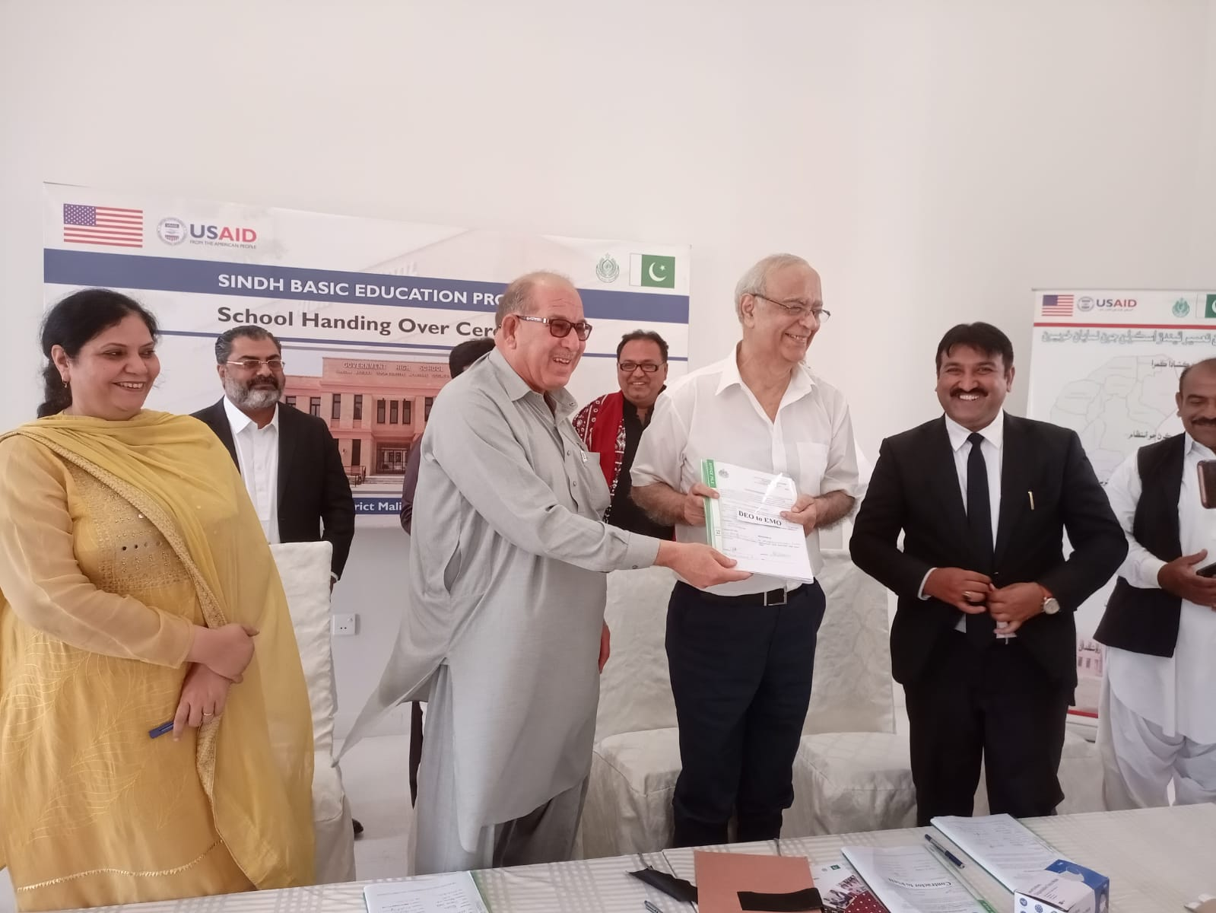

STAFF BIO DATA
GHS Sindhi Jamaat Co-Operative Housing Society, Bin Qasim Town Karachi
Year 2022-2023 - Semis Code# 408170153
S No | Name | Designation | Personal ID | CNIC No | Date of Birth | Date of Appointment | Present School Joining Date | Qualification
1 | Arbab Ali Lashari | PST | 10091196 | 42501-8059611-9 | 6-Feb-1963 | 11-Feb-1981 |  | Inter, P.T.C
2 | Suhail Ahmed | PST | 10228963 | 43205-9597118-1 | 5-Mar-1982 | 21-Dec-2001 | 24-Sep-2019 | M.A, M.Ed
3 | Hafeeza Khatoon | PST | 10083703 | 43203-7039576-4 | 10-May-1971 | 1-Sep-1992 | 19-Apr-2018 | B.A, B.Ed
4 | Mrs. Sajida | PST | 10409986 | 43504-0564937-4 | 14-Apr-1968 | 4-Nov-1990 | 3-May-2018 | M.A, M.Ed
5 | Mrs. Ambreen | ECT | 10966851 | 42501-0563583-2 | 28-Feb-1988 | 9-Mar-2020 | 10-Mar-2020 | M.A, B. Ed
NON-TEACHING STAFF
1 | Muhammad Ejaz | Peon | 10780737 | 42201-0778985-5 | 14-Aug-1976 | 16-Aug-2011 | 20-Feb-2016 | Matric

STAFF BIO DATA
GHS Sindhi Jamaat Co-Operative Housing Society, Bin Qasim Town Karachi
Year 2023-2024 - Semis Code# 408170153
S No | Name | Designation | Personal ID | CNIC No | Date of Birth | Date of Appointment | Present School Joining Date | Qualification
1 | Abdul Ghaffar | HST |  |  |  |  | 12-Sep-2023 | MSC, M.Ed
2 | Mrs. Parveen Bhutto | HST | 10058374 | 42201-6003426-2 | 1-May-1975 | 10-Jan-1996 | 26-Oct-2023 | M.A, M Ed
3 | Mrs. Erum Ansari | JST | 10833448 | 45304-3957957-8 | 1-Jan-1980 | 6-Apr-2015 | 27-Oct-2023 | BS Computer, M.Ed
4 | Mrs. Saima Jamali | JST |  |  |  |  | 29-Oct-2023 | B.A, M.Ed
5 | Mrs. Naila Magsi | PST |  | 42501-3745991-0 | 20-Jun-1990 | 21-May-2024 | 21-May-2024 | B.A
6 | Mr. Ayaz Ahmed | PST |  | 45302-3434531-3 | 25-Mar-1988 | 22-May-2024 | 22-May-2024 | M.A, B.Ed
7 | Muhammad Anwar | PST |  | 42501-6588578-1 | 6-Jul-1996 | 23-May-2024 | 23-May-2024 | M.A
NON-TEACHING STAFF
1 | Muhammad Ashraf | Peon | 10304582 | 42501-6433525-1 | 1-Jul-1971 | 8-Jul-2011 | 1-Mar-2024 | Primary

STAFF BIO DATA
GHS Sindhi Jamaat Co-Operative Housing Society, Bin Qasim Town Karachi
Year 2024-2025 - Semis Code# 408170153
S No | Name | Designation | Personal ID | CNIC No | Date of Birth | Date of Appointment | Present School Joining Date | Qualification
8 | Mrs.Gulshad Gul | PST | 1108342 | 42000-6997672-2 | 1-Jan-1995 | 9-Jun-2022 | 18-Jan-2025 | B.Ed, B.Com
9 | Mr. Amjad Hussain | JST | 11021020 | 42501-6407218-1 | 1-Aug-1996 | 3-Oct-2022 | 18-Jan-2025 | B.E, B.Ed
10 | Mrs. Zakia Rehman | O.T | 10475117 | 45401-4767823-4 | 5-Jul-1977 | 14-Sep-2004 | 18-Jan-2025 | M.A

